**Project Title** : Signs with smart connectivity for better road safety

**Team ID** : PNT2022TMID44536

**Project Design Phase – I** : Solution Fit Template

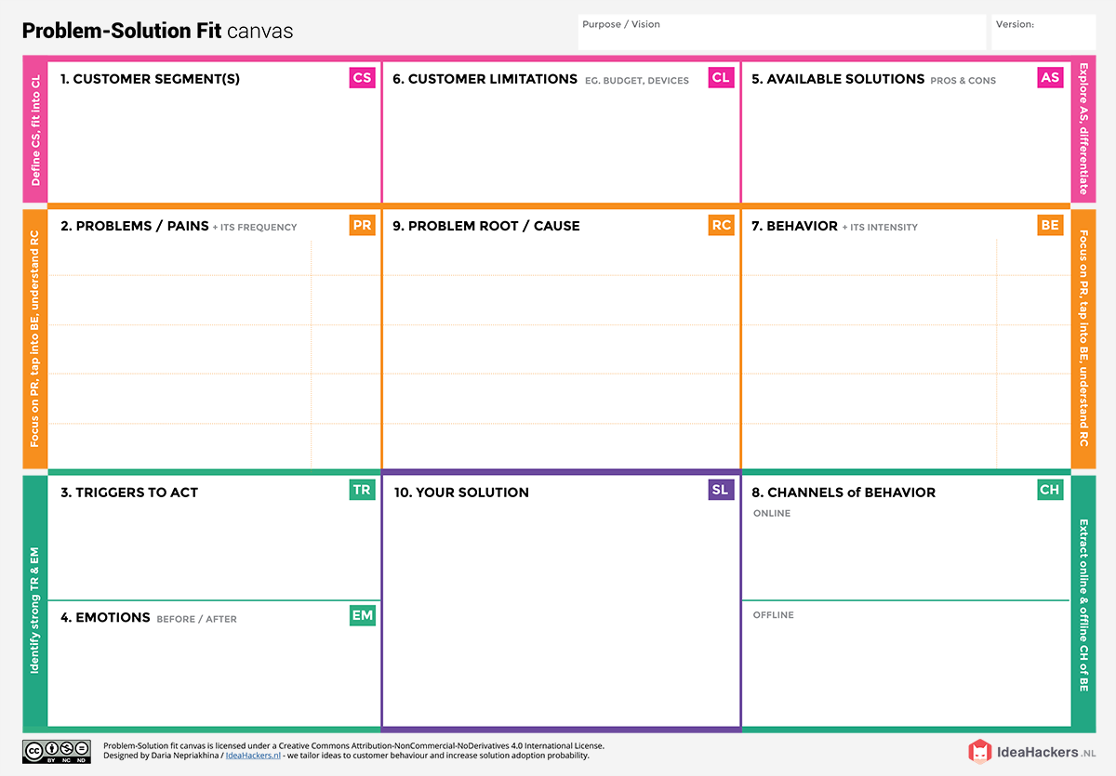

The people feels panic, afraid when they face a problem, after that they feel confident and safety.

Sensor Setup

It provides us with certain rules and regulations that describe how one should use roads diligently and in a proper way

Budget and Available device

When two cars pass from the opposite side of a mountaincurve the IR sensor senses the car and LEDcolour changes to red and raises the buzzer giving signal of danger

Many roads have insufficient capacity, poor sidewalks, unlimited crossings and a lack of road equipment and safety measures.

The emotional impact of the accident itself as well as related injuries can lead to depression, withdrawal, isolation, feelings of hopelessness and suicidal thoughts.

Lack of proper information or training, unsafe systems of work, poorly maintained or unsuitable equipment, poor planning, unclear responsibilities, poor supervision

The behavior such as age, experience, gender, attitude, emotions, fatigue, drowsiness, driving conditions

Create awareness among the road users on road safety aspects, with particular focus on drunken driving and over speeding.

IR sensor senses the car and LED

colour changes to red and raises the buzzergiving signal of danger and then it changes oneLED colour into green to allow the one car topass and then the other LED colour turnsgreen. In this way we can prevent theaccidents of curved road.

Install and operate the IR Sensor detectionsystem software.